Take what you need.

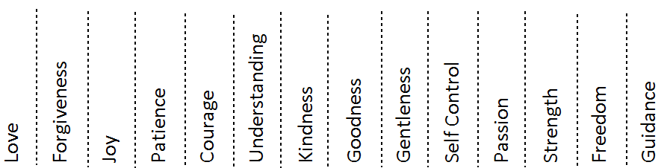

Look at your reflection in the mirror. How do you see yourself?
Do you have confidence in who you are? How does God see you?
Pray these words from Psalm 129 three times:

Lord, it was You who formed my inward parts;
You knit me together in my mother’s womb.
I praise You, for I am fearfully and wonderfully made.

Write down and prayer request on a sticky note
and pray for others on the wall.

Write a letter.

Think about how God has chosen you
by giving you certain gifts.
Add your gifts to others written here
and think about how you can
use them to serve.

Hold a rock in your hand and think of someone
(it can be yourself) who you need to forgive.
Pray for them and the situation.
Forgive them and add your rock to the water.
Forgive as Jesus forgives you.

How is Jesus calling you to grow?
Write down a goal for the person
you want to become on a piece of paper.

Remember that all things are possible with God.

Think of places on the map in need of prayer.

Light a candle and say a prayer for these places.

How do you picture God? What is God like?
?
Using one color of clay,
make what God personally means or represents to you.

Read the story of Jesus’ crucifixion.

Put a nail in the cross as a reminder that Jesus died for you.

Remember: through the death of Jesus
your sins are dead in the eyes of God.

Mark 15:33-39
When it was noon, darkness came over the whole land until three in the afternoon. At three o’clock Jesus cried out with a loud voice, ‘Eloi, Eloi, lema sabachthani?’ which means, ‘My God, my God, why have you forsaken me?’ When some of the bystanders heard it, they said, ‘Listen, he is calling for Elijah.’ And someone ran, filled a sponge with sour wine, put it on a stick, and gave it to him to drink, saying, ‘Wait, let us see whether Elijah will come to take him down.’ Then Jesus gave a loud cry and breathed his last. And the curtain of the temple was torn in two, from top to bottom. Now when the centurion, who stood facing him, saw that in this way he breathed his last, he said, ‘Truly this man was God’s Son!’

As you enter and as you leave,
make the sign of the cross
on your forehead
as a reminder that
you are a beloved child of God.

Supplies Needed: (Number varies based on size of group.)
- Tape
- Mirror
- Pens
- Paper
- Map
- Candles
- Container with sand for inserting candles.
- Sticky Notes
- Rocks
- Bowl/water
- Clay or Play Doh
- Large Wooded Cross
- Nails
- Hammer
- Various fabrics, candles, decorations to set contemplative tone.

